**Ai Powered Automated Traffic Management System**

**Shanmuga Priya Raanjani SH, Shanmuga Divya K, Gurubaran T**

[**220701262@rajalakshmi.edu.in**](mailto:220701262@rajalakshmi.edu.in)

[**220701261@rajalakshmi.edu.in**](mailto:220701261@rajalakshmi.edu.in)

[**220701522@rajalakshmi.edu.in**](mailto:220701522@rajalakshmi.edu.in)

1. **ABSTRACT:**

Urban mobility is nevertheless significantly hampered by traffic infractions, which lead to traffic bottlenecks, crashes, and a decline in road safety. This article presents an AI-powered Traffic Management System (ATMS) that employs cloud computing, machine learning, and potent computer vision to detect and penalize traffic violations in real time, thereby achieving a Zero Violation Point. The proposed system integrates with the existing CCTV infrastructure to monitor urban traffic flow without requiring the deployment of additional hardware. Using deep learning models like YOLOv8 and OpenCV, the system can accurately detect violations such as drivers without wearing seatbelts, riders without helmets, red light jumping, lane indiscipline, and wrong-way driving. The core of the system is an AI-powered video processing module that continuously analyzes live camera feeds to identify violations and obtain vehicle registration numbers using optical character recognition (OCR). The collected license plate numbers are compared to

government databases (RTO APIs) to retrieve owner information. After successful identification, an automatic e-challan is created and sent to the offender via SMS or WhatsApp notifications to guarantee a seamless fine issuance procedure. While the backend is built using Fast API/Django to manage violation records, PostgreSQL/MongoDB serves as the primary database for recording traffic violations and payment statuses. The technology combines violation detection with AI-driven traffic planning and predictive analytics to increase road efficiency. By analyzing historical traffic data and present congestion levels, the technology makes dynamic recommendations for the optimal traffic signal lengths to minimize delays and improve flow. A specialized officer dashboard (made with React.js/Angular) that provides real-time violation monitoring, statistical insights, and data-driven decision-making tools can be used by traffic authorities to enforce stricter traffic laws. The software also integrates payment mechanisms (Paytm, Razor pay, and UPI) to reduce administrative burden and speed up fine settlements. In contrast to traditional traffic monitoring solutions that rely on expensive hardware setups or manual involvement, this approach stresses a scalable and affordable software-based solution. By utilizing cloud-based processing (AWS Lambda, Google Cloud Functions) and asynchronous task queues (Kafka, Celery), the system ensures exceptional efficiency in managing several live video feeds while maintaining real-time responsiveness. The solution can be implemented gradually, starting with high-violation areas in metropolitan areas and working your way out to larger city networks. One of the main advantages of this system is its automated enforcement approach, which eliminates the need for human policing. This reduces corruption, guarantees fair penalty distribution, and promotes compliance with traffic regulations. Furthermore, the modular architecture of the system enables future enhancements like AI-driven accident prediction models, automatic congestion charges, and connection with smart city platforms. The proposed AI-powered traffic control system aims to revolutionize urban transportation by ensuring optimal traffic flow and lowering violations through astute automation. By creating an efficient and data-driven law enforcement mechanism, the system has the potential to significantly reduce accident rates, improve road discipline, and elevate overall safety standards in urban settings. This research and implementation design provides a practical, scalable, and technologically advanced solution to today's traffic issues, paving the way for future smart cities.

1. **INTRODUCTION**

Urban transportation lies at the heart of every modern city’s lifeline. From daily commutes to emergency services, the smooth flow of vehicles determines how efficiently a city functions. But as our cities grow denser and the number of vehicles increases by the day, we’re faced with a growing set of challenges — traffic congestion, reckless driving, rule violations, and, most alarmingly, preventable accidents. Despite efforts to increase awareness and improve infrastructure, one persistent issue continues to burden our roads: traffic violations. Whether it’s someone jumping a red light, not wearing a helmet, driving against the flow of traffic, or ignoring lane discipline, each small act of non-compliance adds up — causing bottlenecks, risking lives, and stretching our law enforcement thin. Human enforcement alone is no longer scalable or efficient in handling these mounting issues. In this landscape of complexity and urgency, technology offers a powerful promise. The emergence of artificial intelligence (AI), machine learning, and advanced computer vision technologies has opened up new possibilities in traffic management. Our project, the AI-powered Traffic Management System (ATMS), is built on this promise — to bring real-time, intelligent, and automated enforcement to our urban roads. The idea is simple but transformative: what if we could detect violations *as they happen*, identify the vehicle involved, and immediately issue a penalty — all without any manual intervention? What if traffic signals could adapt dynamically based on real-time congestion data? And what if traffic enforcement officers had a smart dashboard that gave them clear insights into trends, hotspots, and behavior patterns on the roads? Our system answers these questions by combining deep learning models like YOLOv8 with powerful image processing libraries like OpenCV to detect a range of traffic violations from existing CCTV camera feeds — no additional hardware needed. Whether it’s identifying a two-wheeler rider without a helmet, or recognizing vehicles running a red light, the system acts in real-time. Once a violation is detected, the vehicle’s license plate is extracted using OCR and cross-referenced with the RTO database to retrieve owner details. From there, an automated e-challan is generated and sent directly to the offender via SMS or WhatsApp, creating a seamless and non-intrusive enforcement pipeline. But the ATMS is more than just a rule enforcement tool. It’s designed to be a comprehensive traffic intelligence system. By analyzing historical patterns and current congestion levels, it makes predictive recommendations for optimal signal timings to reduce delays and keep traffic flowing. The use of cloud computing (AWS Lambda, Google Cloud Functions) and asynchronous processing with Kafka or Celery ensures that the system scales effortlessly, even when managing multiple live feeds simultaneously. To support traffic authorities, we’ve also built an intuitive officer dashboard using React.js or Angular, offering real-time monitoring, interactive maps of high-violation zones, and detailed analytics to guide policy-making and targeted interventions. And with integrated payment gateways like Paytm, UPI, and Razor pay, paying fines is made easier for citizens — promoting compliance while reducing paperwork. What sets this system apart is its affordability, scalability, and focus on automation. In contrast to traditional models that rely on expensive surveillance setups or time-consuming manual checks, our approach uses the city’s existing CCTV infrastructure and modern cloud software to do the heavy lifting. Ultimately, this project is about making our roads safer, our enforcement smarter, and our cities more livable. By reducing human bias, minimizing corruption, and ensuring fair and consistent enforcement, we’re not just solving a tech problem — we’re addressing a societal one. Our vision for ATMS aligns closely with the broader goals of smart city initiatives and can evolve further to include accident prediction models, congestion charges, and even integration with emergency services.

**LITERATURE SURVEY**

**[1**] This article suggests an AI-powered traffic management system that integrates cloud computing, optical character recognition, and computer vision for real-time traffic violation detection and penalty issuance in order to reach Zero Violation Point. The system employs deep learning models (YOLOv8, OpenCV, and EasyOCR) to monitor lane indiscipline, red light jumping, helmetless riders, and seatbelt breaches using the existing CCTV infrastructure. An OCR-based license plate recognition system detects violations and automatically generates e-challans via SMS and WhatsApp using the RTO database. The system's predictive analytics and AI-driven signal optimization ensure efficient traffic flow. This approach increases the precision of infraction detection and aligns with Super-Resolution GAN-based techniques for better vehicle identification in challenging circumstances. By eliminating manual policing, reducing corruption, and enhancing traffic law enforcement, the technology contributes to safer roads and smarter cities. Given its scalability, affordability, and ease of implementation, the proposed method is an excellent choice for updating urban traffic management.

**[2]** In order to ensure zero violation points, this study presents an AI-powered traffic control system that employs computer vision and deep learning to identify infractions in real time and assess fines. The system uses YOLOv8, OpenCV, and OCR to scan CCTV footage and identify traffic violations such as helmet-less riding, seatbelt violations, and red light jumping. Following the retrieval of car license plates using deep learning-based OCR models and cross-referencing with RTO databases, violators are automatically sent e-challans by WhatsApp or SMS. The technique, which is consistent with advanced license plate recognition (LPR) research, employs deep learning techniques to improve identification in complex situations with low-light, skewed, or fuzzy pictures. The software-driven approach eliminates manual enforcement, reduces corruption, and maximizes traffic flow through AI-based predictive analytics, making it scalable, cost-effective, and ideal for integration into smart cities. The system significantly increases road safety and compliance while ensuring seamless digital enforcement of traffic laws.

**[3]**This article presents an ai-powered traffic control system that employs computer vision and deep learning to detect and penalize violations in real time enabling the achievement of zero violation point through the integration of yolov8 OpenCV and ocr the system analyzes cctv feeds to identify helmet-less cyclists seatbelt violations and red light jumping violations are detected using deep learning-based license plate recognition lord and e-challans are immediately distributed by SMS or WhatsApp the approach is consistent with optimal yolov4-based vehicle detection research which uses attention processes and enhanced feature extraction to improve detection accuracy in complex scenarios because it reduces manual enforcement enhances traffic flow using ai-driven predictive analytics and ensures automatic violation tracking the system is scalable cost-effective and ideal for smart city integration this study bridges the gap between deep learning advancements in vehicle detection and automated traffic law enforcement resulting in safer roads and better adherence to traffic laws

**[4]** This article proposes an AI-powered traffic management system that combines computer vision, deep learning, and OCR-based vehicle identification to ensure Zero Violation Point in order to identify and penalize traffic offenses in real-time. Using YOLOv8, OpenCV, and neural network-based OCR, the system analyzes CCTV footage to identify seatbelt violations, lane indiscipline, and motorcycle riders without helmets. After the obtained license plate numbers are matched with RTO databases, violators are automatically sent e-challans through SMS or WhatsApp. In line with neural network-based number plate recognition research, this technique improves plate detection in challenging motion, lighting, and weather conditions. The technique uses deep learning algorithms to improve plate recognition, ensuring accurate identification of criminals. The automated enforcement system increases road safety and compliance by decreasing manual policing. Because of its scalable and reasonably priced architecture, this AI-driven system is ideal for modern urban traffic management. It ensures efficient monitoring, fewer violations, and optimized traffic flow in smart cities.

**[5]** This study presents an AI-powered traffic management system that strives for Zero Violation Point by integrating computer vision, deep learning, and OCR-based vehicle identification for real-time traffic violation detection and penalty issues. The system uses neural network-based OCR, OpenCV, and YOLOv8 to scan CCTV footage and identify violations like helmet-less riding, red-light jumping, and seatbelt violations.To increase detection accuracy, vehicle license plates are re-identified across many surveillance zones using CNN-based re-ranking algorithms. This approach is in line with zone-specific vehicle re-identification research and enhances traffic rule enforcement and violation tracking across many sites. By automating fine issuing through connection with RTO databases and digital notifications, the solution eliminates manual policing, increases compliance, and reduces corruption. Through intelligent automation, the system ensures safer roads and improved traffic management, making it scalable, cost-effective, and ideal for smart city applications. It consists of strategic zone surveillance and AI-powered traffic analytics.

**[6]** In order to achieve zero violation points, this study presents an AI-powered traffic control system that employs real-time infringement recognition and automatic penalty issuance. Using refined YOLOv4, OpenCV, and OCR, the system examines CCTV footage to find violations like helmet-less riding, red-light jumping, and seatbelt non-compliance. Following the retrieval of license plates using deep learning-based OCR models and cross-referencing with RTO databases, violators are automatically sent e-challans via WhatsApp or SMS. This approach is consistent with state-of-the-art research on vehicle detection using optimized YOLOv4, which incorporates attention mechanisms and enhanced feature extraction to increase accuracy in challenging environmental conditions. Using zone-based tracking, AI-driven predictive analytics, and automated enforcement, the system ensures efficient violation detection, less manual intervention, and enhanced traffic flow. The scalable and cost-effective architecture of this AI-driven solution, which employs intelligent automation to enhance road safety, law enforcement, and urban mobility, makes it ideal for smart city traffic management.

**[7].** This paper presents an AI-powered Traffic Management System designed to achieve Zero Violation Point through real-time helmet detection and automated fine issuance. Using YOLOv8, OpenCV, and OCR-based license plate recognition, the system processes CCTV footage to identify helmet-less riders, seatbelt violations, and red-light jumping. The extracted license plate numbers are cross-referenced with RTO databases, and violators receive automated e-challans via SMS/WhatsApp. This approach aligns with transformer-based helmet detection research, integrating Deformable Attention and Swin Transformer-based feature extraction to enhance detection accuracy in real-world traffic conditions. By incorporating AI-driven traffic analytics and deep learning-based predictive modeling, the system improves violation detection efficiency, reduces manual intervention, and enhances law enforcement automation. With its cost-effective, scalable architecture, this solution supports smart city traffic management, ensuring safer roads, improved compliance, and intelligent urban mobility through data-driven enforcement mechanisms.

**[8]**This article presents an ai-powered traffic management system that integrates computer vision deep learning and ocr-based vehicle identification to detect traffic violations in real time and enforce penalties in order to achieve zero violation point the technology uses yolov8 opencv and paddle ocr to analyze cctv footage in order to identify red-light runners helmet-less bikers and seatbelt violations following the retrieval of license plates using deep learning-based ocr techniques and cross-referencing with rto databases violators receive e-challans via whatsapp or sms this work supports advanced anpr and vehicle recognition models by utilizing yolox mobilenet-v2 and gradcam to enhance real-time accuracy in challenging weather conditions the system combines deep learning for automated law enforcement and vehicle tracking ensuring efficient traffic monitoring reduced manual intervention and enhanced road safety because of its scalable design and ai-driven analytics this system is inexpensive ideal for smart cities and a significant step toward automated traffic law enforcement and better urban mobility

**[9]** In order to achieve zero violation points, this study presents an AI-powered traffic control system that employs real-time infraction detection and automatic fine issuance. The system processes CCTV footage using YOLOv8, OpenCV, and OCR to detect helmetless cyclists, seatbelt violations, and red-light running. Following the retrieval of license plates and their comparison with RTO databases, violators are automatically sent e-challans via SMS or WhatsApp.This approach enhances real-time violation monitoring and aligns with low-light anomaly detection research by utilizing deep learning-based vehicle recognition and image enhancement techniques. By using YOLOv8 for object detection in complex scenarios, the technique ensures improved rule enforcement, reduced false positives, and higher accuracy. With AI-driven predictive analytics and scalable cloud-based deployment, this system eliminates human policing, enhances compliance, and optimizes urban traffic management. The technology's low cost and advanced automation architecture make it ideal for smart city applications, which significantly improve road safety and traffic discipline.

**[10]** In order to attain Zero Violation Point, this article introduces an AI-powered traffic management system that uses automated fine issuing and real-time traffic violation detection. The system uses CCTV surveillance to identify helmet-less motorcyclists, seatbelt infractions, and lane discipline violations using computer vision and deep learning. Violators receive automated e-challans via SMS or WhatsApp once identified vehicles are subjected to OCR-based number plate recognition and cross-referenced with RTO databases.In line with studies on lane-keeping assistance based on Model Predictive Control (MPC), the system improves intelligent traffic optimization, lane adherence enforcement, and real-time vehicle tracking. The method lowers traffic and increases adherence to traffic laws by using MPC for predictive decision-making. Minimal human interaction and effective urban mobility management are guaranteed by the scalable deployment and AI-driven traffic analytics. By incorporating cutting-edge MPC techniques for smart city applications, this system enhances automated law enforcement, lowers accident rates, and guarantees safer roads.

**[11]** This article presents an AI-powered traffic management system that employs computer vision and deep learning to identify and punish traffic infractions in real time, therefore achieving Zero Violation Point. Using YOLOv8, OpenCV, and OCR-based vehicle recognition, the system analyzes CCTV footage to detect seatbelt violations, helmetless riders, and red-light running. When license plate data is obtained and checked with RTO databases, violations are automatically contested via SMS or WhatsApp.This approach is consistent with studies on real-time vehicle classification, which employs XGBoost and feature selection to improve accuracy under challenging environmental conditions. By combining machine learning-based vehicle detection with predictive analytics for traffic flow management, the technology enhances urban traffic law enforcement. Because of its scalable and reasonably priced AI-driven architecture, the system improves rule compliance, eliminates manual enforcement, and aids in traffic control in smart cities.The effectiveness and reliability of traffic enforcement are increased when real-time machine learning algorithms are used to provide precise, automated tracking of traffic violations.

**[12]**In order to accomplish zero infraction point we present an ai-powered traffic management system in this work that employs real-time traffic violation detection and automatic penalty issue using yolov8 opencv and ocr-based vehicle recognition the system analyzes cctv footage to detect red-light running riders without helmets and seat belt violations when violators license plates are identified using deep learning-based ocr models and compared with rto databases automated e-challans are sent via whatsapp or sms this approach increases detection accuracy and aligns with machine learning-based modeling of red-light violations by fusing predictive analytics with celeration analysis by using ai-powered behavior prediction models the solution improves traffic rule enforcement reduces manual participation and offers smarter urban mobility because of its scalable ai-driven architecture this system is deployable reasonably priced and ideal for modern smart cities by using predictive analytics for infractions the system ensures safer roads and improved adherence to traffic laws.

**[13]**In order to accomplish zero infraction point we present an ai-powered traffic management system in this work that employs real-time traffic violation detection and automatic fine issuing the system employs yolov8 opencv and ocr-based license plate identification to detect helmet-less cyclists seat belt infractions and red-light running from cctv footage violators receive automated e-challans via sms or whatsapp when the retrieved license plate numbers are compared with rto databases this dad in order to improve accuracy in difficult scenarios this work provides transformer-enhanced yolov8-based helmet identification which makes use of repconv and coordinate attention modules by fusing deep learning-based object detection with ai-driven predictive analytics the system ensures precise automated monitoring of traffic violations its scalable and cost-effective architecture makes it ideal for traffic management in smart cities significantly enhancing law enforcement efficacy reducing the need for manual intervention and improving road safety through intelligent automation

**[14]**In order to attain zero violation point this article introduces an ai-powered traffic management system that uses automated fine issuing and real-time traffic violation detection the system recognizes helmetless riders seatbelt violations and red-light running from cctv footage using yolov8 opencv and ocr-based license plate identification violators receive automated e-challans via whatsapp or sms when the retrieved vehicle information is compared with rto databases by utilizing swin transformer and deformable attention techniques to improve detection accuracy in difficult ambient situations and occlusions this method is consistent with transformer-based helmet detection studies the solution guarantees effective automated monitoring of traffic infractions by combining ai-driven predictive analytics with deep learning-based object detection this technology increases traffic law compliance does away with manual enforcement and helps create smart city traffic thanks to its affordable scalable architecture management, enhancing law enforcement efficiency and road safety.

**[15]**Automation in vital safety applications including building site monitoring has been made possible by the quick development of deep learning by precisely identifying helmets the improved yolov8 object identification model presented in this paper increases worker safety in the construction industry the model achieves better generalization and avoids overfitting by using test time augmentation tta and picture adjustments such as histogram equalization gamma correction gaussian blurring and contrast stretching by averaging confidence scores across several altered images a novel test time augmentation-based confidence thresholding ttact formula is presented increasing detection robustness the suggested method greatly improves the models recall and precision guaranteeing accurate helmet detection in a variety of settings according to experimental results the system performs better than conventional yolov8 implementations which makes it suitable for practical use.

**[16]** This review examines ai-driven approaches key element of intelligent transportation systems it evaluates machine learning deep learning and hybrid frameworks assessing their precision in forecasting and processing efficiency findings indicate that deep excel in modeling time-dependent traffic trends the study also identifies challenges such as data inconsistencies abrupt congestion spikes and the demand for instantaneous prediction capabilities the authors suggest that hybrid systems merging complementary ai methodologies yield superior results compared to standalone models they further highlight the importance of embedding contextual variables like weather conditions social events and roadwork into prediction algorithms to boost reliability by addressing these factors ai models can better anticipate disruptions and adjust traffic management strategies dynamically the paper underscores ai-driven predictions to enable proactive optimization reducing bottlenecks urban mobility however it calls for continued research to refine real-time adaptability and ensure robust performance under diverse unpredictable scenarios.

**[17]**This study investigates the application of drl for adaptive urban networks the authors introduce a distributed framework where individual traffic lights function as autonomous agents optimizing signal timing rough of diverse congestion scenarios the approach achieves notable decreases in idle times buildup relative to conventional fixed-cycle systems a core advancement involves cooperative learning among agents which exchange traffic insights with adjacent junctions to improve regional synchronization tests reveal that drl-based strategies consistently surpass conventional fixed-timing approaches particularly during erratic or high-demand periods indicating viability for scalable solutions in urban mobility while the research acknowledges limitations such as processing demands and the need for rapid fluctuations it underscores promise ai-driven in revolutionizing.

**[18]** This research introduces a vision-driven ai framework for traffic management leveraging convolutional neural networks cnns to analyze real-time footage from roadside cameras instead of conventional sensor-based setups the system autonomously modifies traffic signal timings according to detected congestion levels at intersections aiming to optimize vehicle flow urban trials revealed significant reductions in wait times and enhanced traffic efficiency compared to static signal systems by substituting hardware-dependent sensors with camera-based solutions the approach offers a cost-efficient alternative to existing infrastructure improving scalability for widespread deployment however limitations such as inconsistent performance under fluctuating lighting or obstructed views eg occluded vehicles are acknowledged underscoring the need for advanced vision algorithms to handle environmental variability the study advocates for ai-powered systems as a pathway to adaptive hardware-light traffic control though emphasizes refining model robustness for real-world complexities this innovation demonstrates the potential of computer vision in creating agile resource-efficient urban mobility solutions.

**[19]** This study explores a decentralized traffic signal utilizing where each intersection operates as an autonomous agent by enabling agents to independently learn policies aimed at reducing bottlenecks and delays enhances disruptions like partial failures or fluctuating demands the authors introduce a collaborative reward-sharing mechanism incentivizing agents to optimize local traffic flow while accounting for cascading effects on adjacent intersections simulations demonstrate that markedly enhances efficiency particularly during peak periods and unplanned congestion events to address scalability the paper proposes a hierarchical learning architecture enabling coordination across large networks without centralized oversight the findings emphasize that distributed ai-driven methods offer greater adaptability and feasibility for dynamic urban environments compared to rigid centralized models this approach bridges robustness and real-time responsiveness in evolving traffic ecosystems**.**

**[20]** this study investigates merging internet of things iot to develop an intelligent traffic management framework for smart cities the system connects iot devices including gps trackers cameras environmental sensors with analytics track forecast manage dynamically ml-based anticipate trends while optimization algorithms via connected navigation systems trials in test cities demonstrated notable reductions in average commute durations and fuel usage highlighting operational efficiency the authors stress the necessity of robust cybersecurity advocating for end-to-end encryption in data exchanges between devices and centralized platforms they assert that combining ais adaptability with iots real-time data capabilities creates a scalable framework adaptable to expanding urban areas the paper concludes by underscoring the this ecosystem enabling seamless coordination between infrastructure.

**SYSTEM ARCHITECTURE AND COMPONENTS**

A thorough AI-powered framework for e-challan A thorough AI-powered framework for e-challan issuing and traffic violation detection is depicted in the system architecture diagram that is supplied. CCTV cameras placed throughout different locations start the process by continuously recording video feeds. The AI Processing module receives these data and uses the YOLOv8 model to identify traffic infractions including signal jumping and helmetless riding. OpenCV is used to improve the image and separate significant features, such as the vehicle's license plate, from the detected frames.The offender is then identified using an OCR (Optical Character Recognition) module that takes the alphanumeric information from the plate. Cloud services like Google Cloud Functions and AWS Lambda are activated to manage processing activities effectively and in real time after the pertinent data has been collected. These serverless platforms guarantee continuous operation and scale easily to meet demand. Depending on the information's structure, the extracted and processed data—which includes the infraction type, vehicle number, date, and time—is either saved in a PostgreSQL or MongoDB database. An Officer Dashboard, created with React.js and Angular, makes this data available and makes it simple for traffic authority to view, confirm, and handle infractions. The car owners receive notifications from the system at the same time. In order to ensure timely delivery and action, these e-challans—which include the violation information and payment links—are sent via integrated WhatsApp and SMS services. The design incorporates a payment system that enables PayTM, Razorpay, and UPI options to enable easy fine payments. The loop is closed when a successful payment causes the status to be automatically updated in the database and displayed on the officer dashboard.From violation detection to penalty payment, this system simplifies the entire process, making it incredibly effective, scalable, and user-friendly. The architecture has been carefully crafted to provide scalability, modularity, and realtime performance in addition to the basic workflow, which makes it appropriate for deployment in both smaller urban centers and high-density metropolitan areas. The system is able to recognize a wide range of traffic offenses under a variety of environmental situations, such as busy roads or low lighting, by utilizing the robustness of OpenCV for image preprocessing and the power of deep learning with YOLOv8. OCR is essential for recovering license plate information even in cases where the plates are partially obstructed or slanted, increasing the system's dependability. By incorporating cloud computing services like AWS Lambda and Google Cloud Functions, the system gains flexibility and can process several video streams simultaneously without requiring a large amount of physical hardware. This ensures that the system can be easily expanded when the city's monitoring network grows, while also reducing running costs. Furthermore, PostgreSQL and MongoDB offer flexibility in handling both structured and unstructured data, making it easier to store and retrieve files efficiently for reporting and analytical requirements. The officer dashboard gives authorities access to real-time data, violation heatmaps, and predictive analytics to enhance law enforcement and policymaking. Additionally, the payment gateway integration reduces client resistance to fine payments by ensuring a seamless transaction process. This end-to-end design demonstrates an intelligent, automated, and scalable response to the challenges of modern traffic management. issuing and traffic violation detection is depicted in the system architecture diagram that is supplied. CCTV cameras placed throughout different locations start the process by continuously recording video feeds. The AI Processing module receives these data and uses the YOLOv8 model to identify traffic infractions including signal jumping and helmetless riding. OpenCV is used to improve the image and separate significant features, such as the vehicle's license plate, from the detected frames.The offender is then identified using an OCR (Optical Character Recognition) module that takes the alphanumeric information from the plate. Cloud services like Google Cloud +

**SYSTEM ARCHITECTURE**

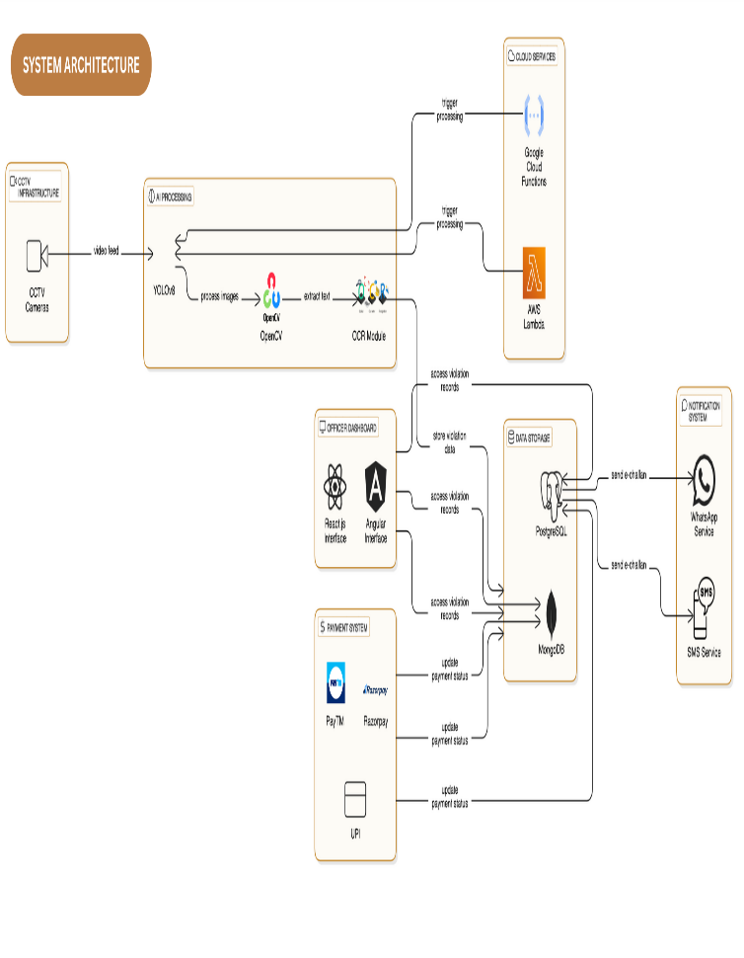

**IMPLEMENTATION**

Building an AI-powered Traffic Management System (ATMS) requires a carefully organized and sequential workflow to ensure smooth operation — starting from capturing live video feeds to detecting violations and processing penalties. The initial phase focuses on setting up a video ingestion pipeline, where real-time streams from various traffic points are collected using RTSP (Real-Time Streaming Protocol). To efficiently manage multiple camera feeds at once, asynchronous task queues like Kafka or Celery are implemented, allowing for better load distribution and maintaining system responsiveness during high-traffic periods. Once the video streams are ingested, the system's core video processing engine comes into play. Using YOLOv8 along with OpenCV, it analyzes each frame to detect various traffic violations, such as riding without a helmet, not wearing a seatbelt, running red lights, or improper lane usage. Advanced object detection and tracking methods ensure accurate identification and monitoring of vehicles and riders across consecutive frames. Simultaneously, an Optical Character Recognition (OCR) module reads license plates when a violation is detected. To enhance accuracy, the OCR output is validated and enriched by connecting to official databases, retrieving critical details like the vehicle owner's name, type of vehicle, and registered contact information. Upon confirming a violation, the system promptly generates an electronic challan (e-fine) and dispatches it to the offender through messaging platforms like WhatsApp or SMS. Integration with digital payment gateways such as Paytm, Razorpay, and UPI further streamlines the payment process, reducing the need for manual intervention and enhancing the ur experience. Additionally, an administrative dashboard built with frameworks like React.js or Angular offers real-time visualization of violations, fine collection statuses, heatmaps of accident-prone areas, and traffic pattern analytics. This dashboard also aids in efficient record management, system health monitoring, and easy deployment of future updates. Deploying an AI-based Traffic Management System (ATMS) involves a structured, multi-stage process to ensure seamless integration and real-time responsiveness. The workflow begins with acquiring live video streams from networked cameras installed across key traffic junctions. These feeds are transmitted via Real-Time Streaming Protocol (RTSP) to a centralized processing hub. To handle concurrent data streams without latency, asynchronous processing frameworks such as Apache Kafka or RabbitMQ are employed, enabling scalable resource allocation during peak traffic hours.At the core of the system lies a computer vision engine powered by YOLOv8, a state-of-the-art object detection model, combined with OpenCV for frame-by-frame analysis. This module identifies traffic violations—including helmetless riders, seatbelt non-compliance, signal breaches, and erratic lane usage—while maintaining vehicle tracking consistency through algorithms like DeepSORT. Parallel to this, a dedicated text recognition subsystem extracts license plate details from violation instances using OCR tools such as Tesseract or cloud-based APIs. To verify extracted data, the system cross-references license plate numbers with regional motor vehicle registries via secure APIs, retrieving owner profiles, vehicle classifications, and contact details.Upon validation, automated workflows trigger instant e-challan generation, delivering fines via SMS, email, or messaging platforms like WhatsApp. Integration with payment processors (e.g., Stripe, BharatPe) allows violators to settle penalties directly through embedded links, minimizing administrative overhead. For transparency, each challan includes timestamped violation evidence, such as annotated video clips or snapshots.A cloud-hosted analytics dashboard, developed using modern frontend frameworks like Vue.js or Next.js, provides authorities with dynamic monitoring interfaces.

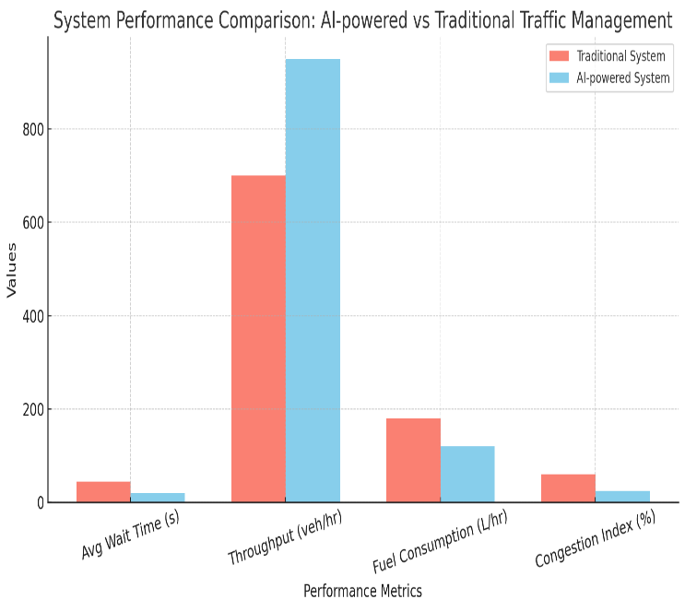

### **REAL-TIME DATA HANDLING**

One of the major strengths of AI-driven traffic management systems is their ability to efficiently manage real-time data. These platforms continuously capture live video feeds from CCTV cameras installed across the city and instantly analyze them to detect traffic violations. To ensure swift and reliable enforcement, it is crucial that data collection, transmission, processing, and analysis occur seamlessly and without delay. The system architecture leverages asynchronous processing tools like Kafka and Celery to manage the large volume of incoming data. By separating video feed ingestion from the core violation detection processes, the system is able to handle multiple tasks simultaneously. This modular setup enables the system to process several live streams at once, ensuring scalability even as traffic volumes grow or more surveillance points are introduced—without impacting performance. To further optimize video stream processing, serverless cloud technologies such as Google Cloud Functions and AWS Lambda are utilized. These platforms automatically scale with demand by executing specific tasks for each incoming video feed, reducing the dependency on traditional server infrastructure. As a result, the system remains cost-effective, highly responsive, and adaptable to fluctuating traffic conditions. Traffic authorities are provided with a real-time dashboard that displays live traffic statistics, alerts, and updates on detected violations. This dashboard supports fast decision-making and rapid enforcement actions. Seamless integration between system components is maintained through the use of WebSockets and RESTful APIs, ensuring real-time synchronization and continuous data flow.Recognizing the critical need for uninterrupted operations, the system incorporates robust fault-tolerance features and redundancy mechanisms to counteract potential network failures or hardware malfunctions. all video streams are also safely timestamped and stored creating a trustworthy record for study and future reference in summary the system’s capacity to efficiently handle real-time data serves as the foundation for an scalable   opening door for urban mobility and next-generation municipal infrastructure.

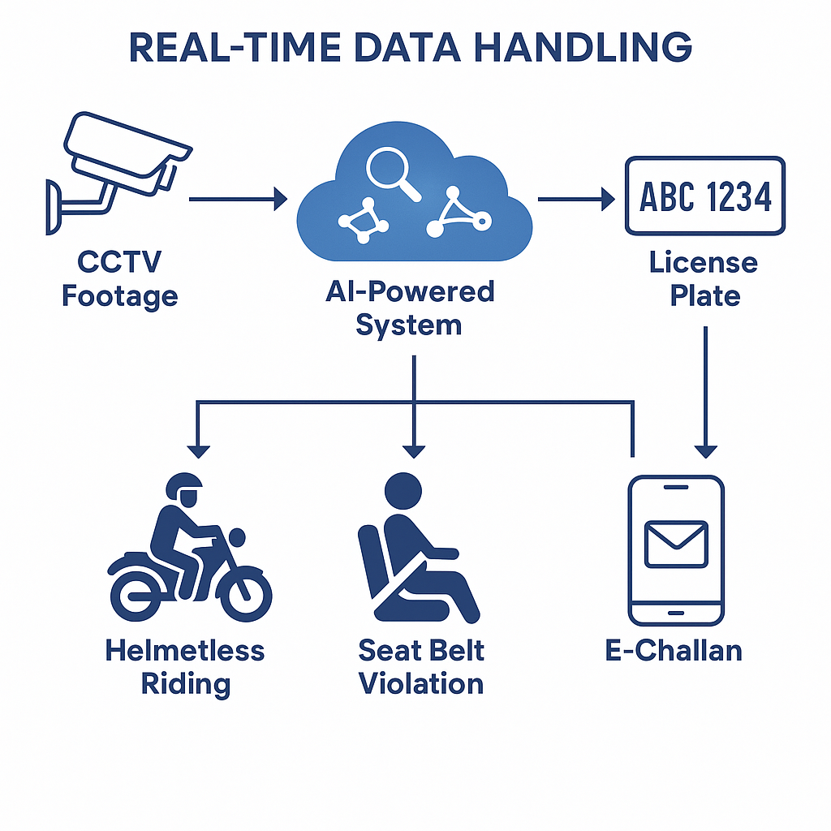

**DATA PREPROCESSING**

A crucial step in improving the precision, effectiveness, and dependability of traffic infraction detection systems is data preprocessing. In this step, unprocessed video footage is converted into a structured format that is best suited for AI model analysis. Even complex models like YOLOv8 may suffer from visual noise, inconsistent illumination, distortions, or superfluous background features filtered to remove any static or unnecessary portions OpenCV. By concentrating primarily on frames with possible violations, this selective filtering reduces the computational strain done to maintain consistent input quality under a range of illumination conditions by ensuring constant resolution for every frame histogram equalization is one technique for enhancing crucial visual components including helmets traffic signals and vehicle motions object extraction is another crucial step in the preprocessing procedure yolov8 is responsible for recognizing significant things including license plates cars and riders following the isolation of license plates optical character recognition orc systems convert the visible text into a digital format that can be read by machines and OpenCV technologies are then utilized to precisely crop these detected portions this increases orc accuracy especially for partially obscured or unclean tilted plates before moving on to the violation detection phase faulty data should be removed and important metadata like camera id timestamps and location information should be attached for better tracking and traceability lastly data validation is done to ensure the quality of the processed input.

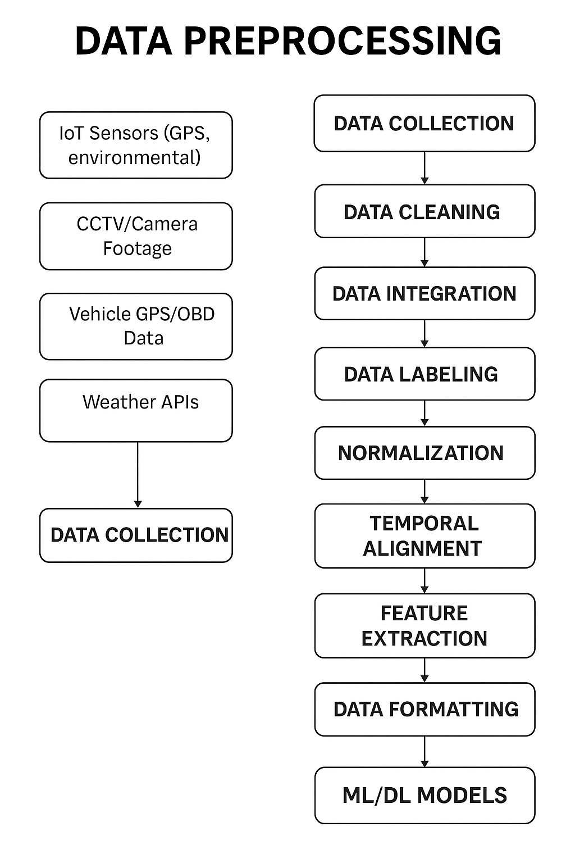

**MODEL TRAINING**

An AI-powered Traffic Management System (ATMS) begins with model training, where the system learns to recognize and categorize different types of traffic infractions from visual data. The YOLOv8 model, a cutting-edge real-time object identification technique, was selected for this project. Curating a sizable, varied dataset of pictures and video frames taken at traffic intersections is the first step in the training process. Bounding boxes and labels indicating the sort of infraction—helmetless riding, not wearing a seatbelt, driving in the wrong direction, red light jumping, etc.—are manually added to these frames.   
The YOLOv8 model receives the labeled data. The model uses a technique known as backpropagation to modify its internal parameters while processing these annotated samples during training. Reducing the discrepancy between the actual bounding boxes and class labels in the training data and the ones that were predicted is the goal. A loss function computes this difference and directs the model's weight changes. In order to expose the model to a variety of lighting, angles, and weather situations, the training data is usually enhanced using techniques like rotation, zoom, flipping, and brightness change. These additions improve robustness and generality. The complete dataset is run through the model several times in what are called epochs, and training is done in batches. The model improves its comprehension of spatial relationships, object actions, and visual patterns with eachepoch. Learning rates are carefully adjusted, and optimizers such as Adam or SGD (Stochastic Gradient Descent) are used to avoid overfitting and increase convergence speed. Utilizing pre-trained weights on sizable datasets, such as COCO, is another way to take use of transfer learning. This drastically lowers the quantity of data and time needed to properly train the model.

**MODEL TESTING**

Testing is an essential stage after establishes how effectively model generalizes outside of environment and how on unfamiliar a unique dataset that was not used for trainingtypically 10 to 20 of the total datasetis used for testing in the ai-powered traffic management system atms red light jumping lane indiscipline and helmetless riding are just a few of traffic violation events were captured dataset varied camera traffic densities the fundamental purpose of model testing is to consistency of predictions crucial performance include mean average precision map recall f1 score and precision while precision indicates how many predicted violations were accurate recall reflects how many actual breaches were accurately identified in particular map evaluates performance across all categories sorts of violations and acts as a typical benchmark for object detection jobs another element of testing is building a confusion matrix that indicates true positives false positives real negatives and false negatives this study identifies key instances in which the model may perform poorly such as presuming that a biker wearing black headgear is wearing a helmet or that a pedestrian is traveling in the incorrect way to ensure that the model can evaluate frames without latency in real time a critical characteristic when applied on live cctv cameras latency tests are also run edge occurrences and borderline breaches are thoroughly evaluated to assess robustness test findings are utilized to guide iterative improvements and if consistent errors are detected those examples are contributed to the training data in succeeding retraining cycles the atms model is eventually evaluated thoroughly to guarantee that it is not only accurate but also fair speedy and appropriate for application in high-stakes urban traffic scenarios.

**MODEL ENHANCEMENT**

Model refinement is an ongoing and vital process that guarantees the ai system learns to match real-world demands adapt to changing traffic scenarios and handle edge cases with precision after the first deployment of the yolov8-based detection model in the traffic management system adjustments are conducted based on real-time feedback error patterns and newly identified violation scenarios that were not well-represented in the original one of the major approaches enhancement incremental learning periodically retraining with new data collected post-deployment these new frames especially those where the model provided erroneous predictions or failed to detect violations are labeled and put into the training pipeline this maintains the model updated with shifting patterns such as changes in vehicle sorts new road layouts or changed lighting conditions adjustment is another route for development by fine-tuning confidence thresholds the be improved to balance detection speed and accuracy additionally model pruning and quantization are applied to reduce model size and inference time without significantly reducing accuracy essential for real-time deployments on edge devices or limited-resource systems further enhancement comes through ensemble learning where numerous trained on diverse subsets or are linked to improve resilience for example while yolov8 can be superb at recognizing autos a complementary lightweight cnn model could be trained only for helmet identification boosting specialization and precision integration with feedback systems also adds benefit traffic officers utilizing the dashboard can flag misdetections or missed infractions forming a loop that directly feeds into future model updates through these tactics the atms model becomes more flexible trustworthy and scalable making it a smarter system capable of handling intricate urban traffic patterns with enhanced efficiency and dependability.

**APPLICATION FEATURES**

**1. Edge Computing for Violation Detection**   
Edge computing greatly enhances responsiveness in traffic violation detection by processing data locally instead of dependent on centralized cloud servers. Advanced models like as YOLOv8 are embedded directly into edge devices like smart cameras or roadside gateways, enabling instant analysis of traffic offenses such as red-light running, unauthorized lane changes, or helmetless riding without latency delays. This method is especially successful in regions with unstable internet connectivity, ensuring uninterrupted surveillance. By evaluating film on-site and uploading only critical alerts or metadata to the cloud, bandwidth utilization is lowered, operational expenses are cut, and data privacy is enhanced. Future advancements could entail federated learning, allowing decentralized model training while ensuring data.

**2.SmartCityIntegration**   
The upgraded AI-based system (ATMS) can smoothly interact with smart city ecosystems, increasing urban transportation management and infrastructure planning. Real-time data, including congestion and violation trends, can dynamically change public transport timetables and facilitate speedier emergency service navigation. City planners can leverage this data via digital dashboards to spot high-traffic zones and execute targeted upgrades. Additionally, connecting ATMS with environmental sensors helps correlate traffic patterns with air quality, promoting eco-friendly municipal policy. With improvements in IoT and 5G, ATMS can evolve into a cornerstone of intelligent, networked transportation networks, enabling safer and more sustainable.

**3. Ethical Considerations and Data Privacy**   
As AI monitoring systems advance, problems regarding privacy, openness, and fairness must be addressed. Continuous video monitoring raises worries about personal data exposure, demanding tight compliance with rules such as GDPR and India’s Personal Data Protection Bill. Techniques like anonymization and selective data gathering—such as collecting only license plate details—help lessen privacy risks. Furthermore, AI models must undergo bias checks to ensure fair detection across diverse settings, such as different illumination or vehicle kinds. Transparency measures, including public announcements regarding surveillance zones and rigorous access limitations, promote public trust. By integrating ethical AI concepts, ATMS can boost road safety without compromising citizen rights.

**4. Intelligent Alert and Escalation Mechanisms**   
ATMS offers a dynamic alert system that extends beyond simple infraction detection to ensure fast enforcement. When offenses such as speeding or signal jumping occur, the system issues automatic e-challans and warns offenders. For repeated infractions or significant violations, alerts are escalated to local enforcement officers via secure APIs, providing precise information such as registration numbers, location, and type of violation. High-risk offenders are prioritized for early response, optimizing law enforcement efficiency. Additionally, the technology can provide proactive alerts to cars entering accident-prone locations. By prioritizing key incidents and keeping a violation history, ATMS changes from passive monitoring to active safety enforcement.

5.**Analytics for Accident Prevention**   
Beyond enforcement, ATMS can employ predictive analytics to proactively lower accident risks. By assessing prior data—such as traffic violations, weather conditions, and congestion patterns—machine learning models can detect high-risk zones and peak hours. Visual heatmaps identify accident-prone regions, allowing authorities to implement preventive measures like speed bumps, increased signage, or additional patrols. Techniques such as adaptive signal control further enhance safety in real-time. These prognostic insights also benefit long-term urban planning, driving infrastructure upgrades and public awareness initiatives. Ultimately, integrating accident forecasting transforms ATMS into a proactive tool for boosting road safety and promoting wiser city design.

**6. Adaptive Public Transit Prioritization**

 Integrates ai to prioritize public transportation at intersections extending green lights for buses trams schedules passenger load by synchronizing with gps trackers and onboard sensors it reduces transit delays and encourages the use of eco-friendly mass transit options this feature is particularly effective in cities aiming to reduce private vehicle dependency.

**7. Cross-Platform Driver Behavior Analytics**

Leveraging edge-processed video feeds the system generates granular insights into driver habits such as abrupt braking distracted driving or erratic lane shifts these anonymized datasets help authorities design targeted road identifies recurring risk patterns enabling preemptive interventions like driver education programs.

**8. Weather-Responsive Signal Adaptation**

AI algorithms correlate live weather data (e.g., rain, fog, or snow) with traffic flow to adjust signal timing and phase sequences. For instance, green light durations may be extended during heavy rainfall to minimize abrupt stops on slippery roads. Integrated with meteorological APIs, this feature enhances safety during adverse conditions while maintaining traffic fluidity.

**EXPECTED OUTPUT / RESULT**

The ai-driven traffic management system atms aims to revolutionize urban traffic enforcement by significantly enhancing the detection and handling of traffic violations leveraging cutting-edge computer vision models like yolov8 alongside opencv for real-time video analysis the system can reliably detect critical infractions including helmetless riding failure to wear seatbelts red-light violations lane misuse and driving in the wrong direction it features automatic license plate recognition using ocr technology which is linked with government vehicle databases rto apis to swiftly identify vehicle owners once identification is complete the system automatically issues e-challans through digital channels such as whatsapp or sms ensuring a fast paperless and efficient penalty process integration with popular digital payment platforms like upi razorpay and paytm allows users to pay fines instantly improving convenience and compliance traffic enforcement personnel can utilize a dedicated officer dashboard that supports real-time monitoring live video feeds analytics on past violations and smart tools for informed decision-making the backend infrastructure will maintain a secure and scalable database that tracks payment history repeat offenses and various types of violations moreover the system contributes to smoother traffic flow by delivering live congestion updates and optimized signal timing suggestions through ai-based heatmaps and predictive analytics authorities will be able to pinpoint high-risk accident zones and implement preventive safety strategies effectively.

**CONCLUSION**

The ai-based traffic management system ATMs offers a groundbreaking solution to today’s urban traffic issues utilizing technologies like cloud computing machine learning and edge-based computer vision the system provides an automated scalable and efficient method of traffic law enforcement it minimizes the reliance on human oversight thereby reducing the chances of corruption and promoting fair enforcement practices by integrating seamlessly with current surveillance systems atms remains cost-effective while the use of cloud and edge computing ensures quick and responsive operations features such as instant alerts auto-generated e-challans and integrated digital payment mechanisms enhance both user convenience and administrative efficiency additionally the systems advanced predictive featureslike accident prediction and identification of high-risk zonesextend its usefulness beyond enforcement positioning it as a critical asset in traffic planning and public safety efforts in summary atms holds the promise of transforming traffic governance by fostering road discipline cutting down on violations preventing accidents and contributing to the creation of smarter safer urban environments as cities grow more connected implementing ai-driven systems like this will be vital for ensuring sustainable and intelligent urban mobility.

**REFERENCE**

[1].H. Wang et al., "Super-Resolution GAN and Global Aware Object Detection System for Vehicle Detection in Complex Traffic Environments," in IEEE Access, vol. 12, pp. 113442113462,2024,10.1109/ACCESS.2024.3442484.

[2]. W. Weihong and T. Jiaoyang, "Research on License Plate Recognition Algorithms Based on Deep Learning in Complex Environment," in IEEE Access, vol. 8, pp. 91661-91675, 2020, doi: 10.1109/ACCESS.2020.2994287.

[3]. J. Zhao et al., "Improved Vision-Based Vehicle Detection and Classification by Optimized YOLOv4," in IEEE Access, vol. 10, pp. 85908603,2022,doi10.1109/ACCESS.2022.3143365.

[4]. W. Wu, H. Xinhan, W. Min and S. Yexin, "An automatic system of vehicle number-plate recognition based on neural networks," in Journal of Systems Engineering and Electronics, vol. 12, no. 2, pp. 63-72, June 2001.

[5]. M. Pemila, R. K. Pongiannan, R. Narayanamoorthi, E. A. Sweelem, E. Hendawi and M. I. A. El-Sebah, "Real-Time Classification of Vehicles Using Machine Learning Algorithm on the Extensive Dataset," in IEEE Access, vol. 12, pp. 98338-98351, 2024, doi: 10.1109/ACCESS.2024.3417436.

[6]. B. A. Holla, M. M. M. Pai, U. Verma and R. M. Pai, "Enhanced Vehicle Re-Identification for Smart City Applications Using Zone Specific Surveillance," in IEEE Access, vol. 11, pp. 29234-29249,2023,doi:10.1109/ACCESS.2023.3254893[7]. S. Bose, M. H. Kolekar, S. Nawale and D. Khut, "LoLTV: A Low Light Two-Wheeler Violation Dataset With Anomaly Detection Technique," in IEEE Access, vol. 11, pp. 124951-124961, 2023, doi: 10.1109/ACCESS.2023.3329737.

[8]. M. M. R. Komol et al., "A Review on Drivers’ Red Light Running Behavior Predictions and Technology Based Countermeasures," in IEEE Access, vol. 10, pp. 25309-25326, 2022, doi: 10.1109/ACCESS.2022.3154088.

[9]. T. Mustafa and M. Karabatak, "Real Time Car Model and Plate Detection System by Using Deep Learning Architectures," in IEEE Access, vol. 12, pp. 107616-107630, 2024, doi: 10.1109/ACCESS.2024.3430857.

[10]. J. D. G. Montoya, E. L. S. Teixeira, A. Murilo and R. R. D. Silva, "A Comprehensive Analysis of Model Predictive Control for Lane Keeping Assist System," in IEEE Access, vol. 11, pp. 140216-140228,2023,doi:10.1109/ACCESS.2023 .3342034.

[11]. L. Cheng, "A Highly Robust Helmet Detection Algorithm Based on YOLO V8 and Transformer," in IEEE Access, vol. 12, pp. 130693-130705, 2024, doi: 10.1109/ACCESS.2024.3459591.

[12].  S. Chen, H. Sun, Y. Wu, L. Shang and X. Ruan, "A Helmet Detection Algorithm Based on Transformers with Deformable Attention Module," in Chinese Journal of Electronics, vol. 34, no. 1, pp. 229-241, January 2025, doi: 10.23919/cje.2023.00.346.

[13]. Y. Seth and M. Sivagami, "Enhanced YOLOv8 Object Detection Model for Construction Worker Safety Using Image Transformations," in IEEE Access, vol. 13, pp. 10582-10594, 2025, doi: 10.1109/ACCESS.2025.3527511.

[14]. Yahia Said, Yahya Alassaf, Refka Ghodhbani, Yazan Ahmad Alsariera, Taoufik Saidani, Olfa Ben Rhaiem, Mohamad Khaled Makhdoum, and Manel Hleili, "AI-Based Helmet Violation Detection for Traffic Management System," *Computer Modeling in Engineering & Sciences*, vol. 141, no. 1, pp. 733–749, Aug. 2024

[15]. K. Singh, K. Lohar, and P. Bagora, "Automatic Detection of Traffic Violations Using YOLO Model and Challan Generation," *International Journal of Scientific Research in Engineering and Technology (IJSRET)*, vol. 10, no. 6, pp. 375–380, Dec. 2024.

[16]**.** Y. Seth and M. Sivagami, "Enhanced YOLOv8 Object Detection Model for Construction Worker Safety Using Image Transformations," *IEEE Access*, vol. PP, no. 99, pp. 1–1, Jan. 2025, doi: 10.1109/ACCESS.2025.3527511

[17]. S. Du, T. Li, X. Gong, and S.-J. Horng, "A Hybrid Method for Traffic Flow Forecasting Using Multimodal Deep Learning," *International Journal of Computational Intelligence Systems*, vol. 13, pp. 85–97, Jan. 2020, doi: 10.2991/ijcis.d.200120.001

[18].R. Jiang et al., "DL-Traff: Survey and Benchmark of Deep Learning Models for Urban Traffic Prediction," *arXiv preprint*, arXiv:2108.09091, Aug. 2021

[19].X. Yin et al., "Deep Learning on Traffic Prediction: Methods, Analysis and Future Directions," *arXiv preprint*, arXiv:2004.08555, Apr. 2020.

**[**20].X. Ma et al., "Learning Traffic as Images: A Deep Convolutional Neural Network for Large-Scale Transportation Network Speed Prediction," *arXiv preprint*, arXiv:1701.04245, Jan. 2017**.**